Network Topologies
Task – 1 : Draw and label diagrams of star, bus, and mesh network topologies on paper or using any drawing tool. For each, write one real-world app or service (like WhatsApp, Flipkart, or IPL streaming) that could use that topology and explain why in 1-2 lines.
Solution : Star, Bus and Mesh Topologies
1. Star Topology : In a Star Topology, all devices are connected to one central device such as a switch or hub.
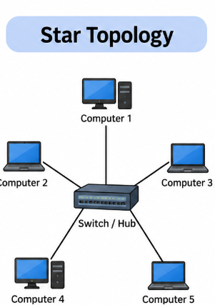
Example : Instagram's servers can use a star-like arrangement within a local data-center network, where multiple devices or servers connect through central switches. This makes the network easier to manage and troubleshoot.
2. Bus Topology : In a Bus Topology, all devices share one main communication cable called the backbone.
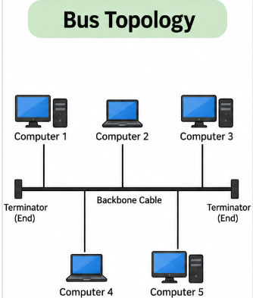
Example: IPL Streaming
A bus-style network could be used in a small or older local setup where multiple devices share the same communication line. However, modern IPL streaming services use much more advanced network architectures.
3. Mesh Topology : In a Mesh Topology, devices have multiple connections with other devices. This provides multiple paths for data to travel.
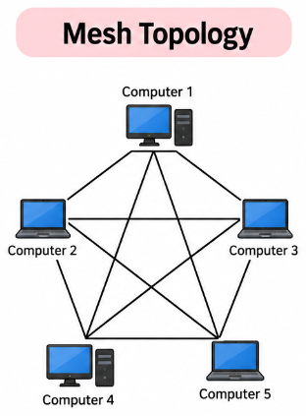
Example: WhatsApp - A large messaging service can use interconnected servers and data centers with multiple network paths. If one path or server becomes unavailable, traffic can be redirected through another available path.

Task – 2 : Create a comparison table listing at least four pros and four cons for each of these topologies: star, bus, ring, mesh. Include a column for 'Best Use Case' and give an example from apps you use (e.g., Instagram, Zomato, Paytm).
Solution : Comparison of Network Topologies
Topology | Pros | Cons | Best Use Case
Star | 1. Easy to install 2. Easy to troubleshoot 3. Failure of one cable affects only one device 4. Easy to expand | 1. Requires a central switch/hub 2. Central device failure affects the whole network 3. More cable is required 4. Can become expensive for large networks | Office LAN, school computer lab, warehouse
Bus | 1. Simple design 2. Low cable requirement 3. Easy to set up for small networks 4. Low initial cost | 1. Backbone failure affects the network 2. Difficult to troubleshoot 3. Performance decreases with more devices 4. Limited expansion | Small/older LAN setups
Ring | 1. Data travels in an organized manner 2. Fewer data collisions 3. Equal access to network 4. Can provide predictable performance | 1. Failure can affect the network 2. Difficult to troubleshoot 3. Adding/removing devices can be difficult 4. Less flexible than star topology | Specialized/legacy networks
Mesh | 1. Very reliable 2. Multiple paths for data 3. No single path failure stops communication 4. Good fault tolerance | 1. Expensive to install 2. Requires many connections 3. Complex to manage 4. Difficult to scale | Critical networks, data centers, wireless mesh networks

Task – 3 : Imagine you are designing a new multiplayer mobile game like PUBG or Free Fire. Choose a suitable network topology for the game servers and justify your choice in 3-4 lines, mentioning how it would impact speed, reliability, and cost.
Solution : Network Topology for a Multiplayer Mobile Game
Mesh / Hybrid Topology
For a multiplayer game like PUBG or Free Fire, I would choose a hybrid topology with interconnected game servers. Multiple servers can communicate through several network paths, which improves reliability and reduces the effect of a single server or connection failure. Players can be connected to the nearest suitable game server to reduce latency and improve speed. Although this setup costs more and is more complex than a simple star network, the reliability and performance are more important for a real-time multiplayer game.
Why?
Player 1 ───┐
Player 2 ───┤
Player 3 ───┼──► Game Server A
Player 4 ───┘ │
│
┌──────┴──────┐
│ │
▼ ▼
Game Server B Game Server C
│ │
└──────┬──────┘
▼
Backup Server
Speed: Players can connect to nearby servers, reducing latency.
Reliability: Multiple servers and paths provide backup if one fails.
Cost: More servers and connections increase infrastructure costs.

Task – 4 : Given this scenario: A small Flipkart-style warehouse wants to connect 8 computers for order processing and inventory updates. Recommend a network topology, sketch a quick diagram, and explain your reasoning in 2-3 lines. Hint : Consider factors like cost, ease of troubleshooting, and future expansion.
Solution : Flipkart-Style Warehouse with 8 Computers
Star Topology
For a warehouse with 8 computers, I would recommend a Star Topology. All computers can be connected to one central network switch. It is easy to install, troubleshoot and expand when more computers or devices are added.
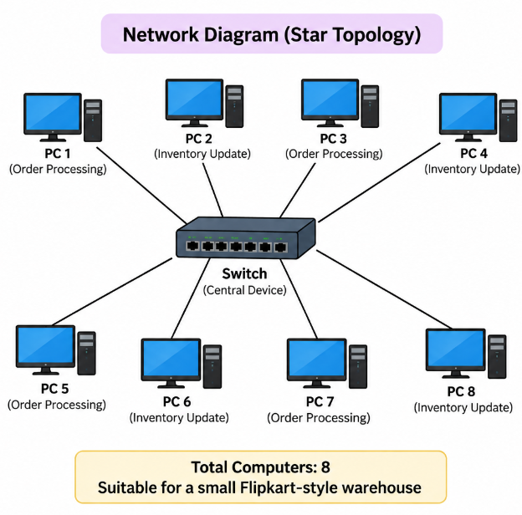
Reasoning
Star Topology is the best choice because it is cost-effective for 8 computers, easy to troubleshoot, and easy to expand. If one computer or its cable fails, the other computers can continue working. A new computer can also be connected to the switch without changing the entire network.

